Name: Umamah Binti Aziz
SAP ID: 72012
Dept: BSCY-03
COAL LAB 12
LAB TASKS
Task 01:
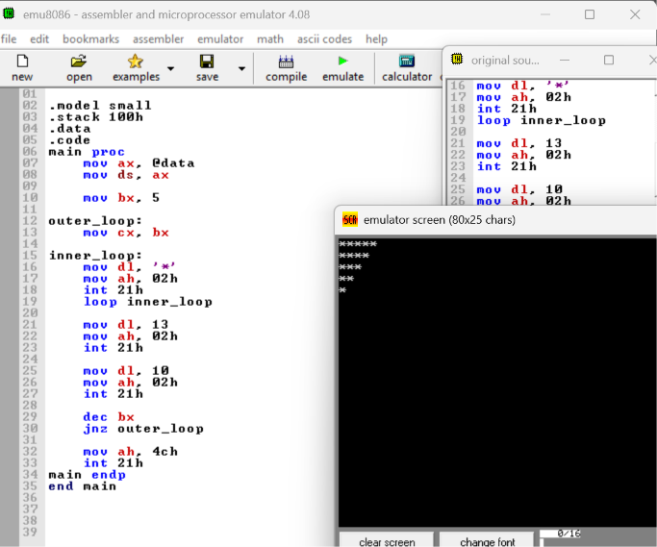

Task 02:
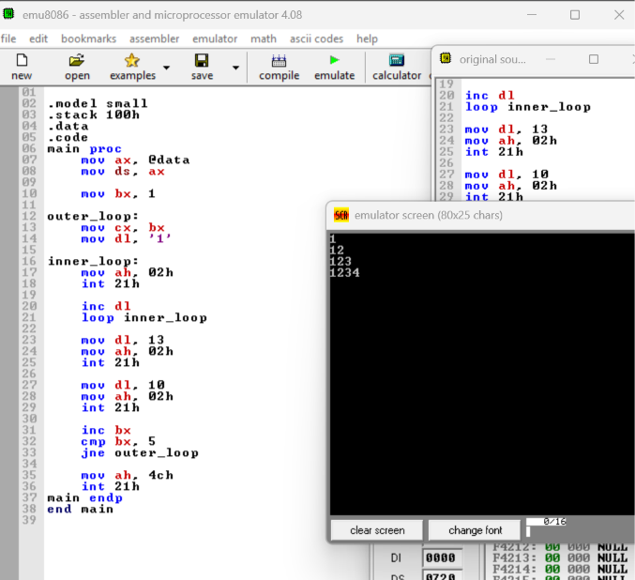

Task 03:


